Study visit

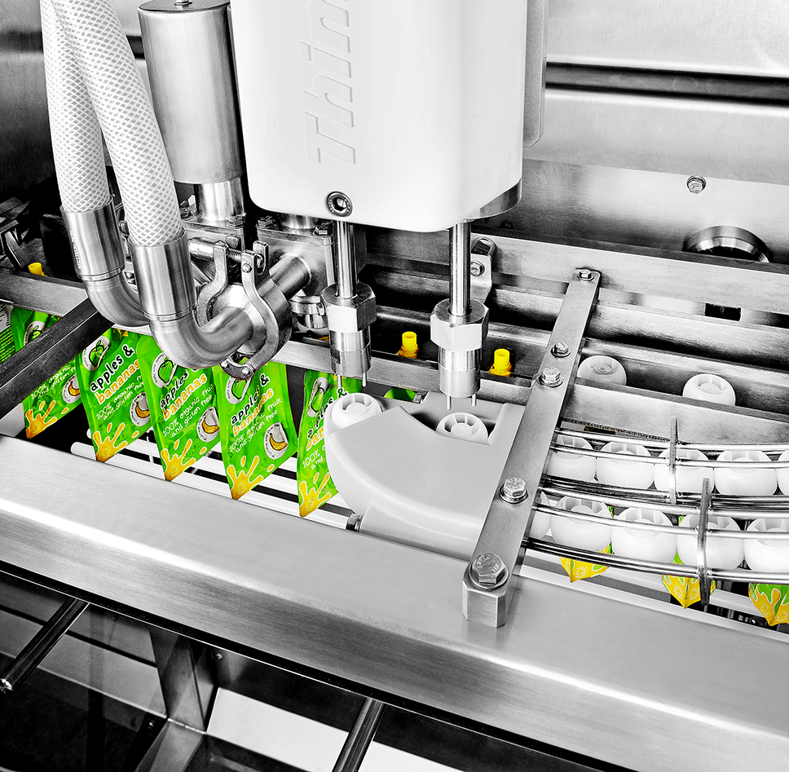

4 February 2020

Villers-le-bouillet, Belgium

SME travel support
650 €

Smart Sensors solutions in AgroFood Companies

Why join?
S3FOOD project will give funds for SMEs who will use innovative
smart sensor solutions related to the agri-food sector.

During this visit you’ll get inspiration about smart sensor solutions
and data collection in the industry, thanks to travel support € 650
  - Visit of an inspiring agri-food company that is using smart sensors
  - Visit of a high tech datacenter, a place where data are stored and secured
  - Testimonial about IoT4Industry project which have similarities to S3FOOD project
  - Short training on this subject by the Microsoft Innovation Center
  - Pitches from technological provider related to smart sensors and agri-food sector
  - Ideation session
Find more information and register at www.s3food.eu

The AGENDA
Tuesday 4/2
Arrival at WALDC | Training by Microsoft Innovation Center
Visit agri-food Company | Visit Wallonie Data Center
S3FOOD introduction | Tech providers presentation
Ideation session | Company testimonials

